**#Lecture 1: Power BI- INTRO-1 | 7 oct 2025**

**#Legends:** Category ko subcategory me convert karta hai.

**#Lecture 2: Intro-2**

If you keep asking questions to your dataset, many many questions it will tell you details and insights. We use power bi becz of search volume and max features.

**What is Power BI:**

Power bi is a business inside/Intelligence tool which allows you to analyze your data, clean your data, and convert that raw data into visual formats like reports dashboards and charts.

Power BI is also known as collection of components.

**1st Component:** Power query editor (ETL TOOL)

**2nd Component:** Power Pivot Table

**3rd Component:** Power View (Visualization chart)

**4th Component:** Power BI service(For publish dashboard)

**Why Power BI:**

* Search Volume
* Max Features

1. 200+ Charts(and we can create our own chart too)
2. 1200+ different M (Mashup) Codes. Jo ETL tool ke andar use hote hai chote chote formula,
3. DAX Query (Data Analysis Expression)—DAX has two types
4. KPI Dax:
5. Column DAX:
6. 200+ different servers to extract data.(Get Data)
7. Power BI is free to use but Power BI services has a cost.
8. Data Connection (can pull data from 200 diff. data source like SQL, Excel, Hadoop)
9. 60% we take data from csv, 20% we take data from excel, 10% from sql and 5% from others.

**#Lecture 3: DAX Queries**

**Two types of DAX queries**

1. **KPI DAX**
2. **Column DAX**

**#ETL Tool Vs Dax Queries in Power BI:**

**ETL tool se agar kaam ho ja raha hai, to kabhii kabhi dax queries use nahi karte, ya phir aesa bhi scenario hota hai ki pura pura dax queries se solve kr lete hai, ETL tool ki zarurat nahi padti, kabhi kabhi dono se kaam chalana padta hai.**

**#Charts in Power BI: There are 3 main charts**

**Line chart, pie chart, column chart**

1. **Ribbon Chart**
2. **Bar Chart**
3. **Line & stacked column chart**
4. **Line & clustered column chart**
5. **Line chart(x axis, y axis, legend)**
6. **Area Chart**
7. **Stacked area chart**
8. **100% stacked area chart**
9. **Histogram and scatter chart(Imp)**
10. **Heat Map**
11. **Box Plot**

**Scatter chart: X and Y axis dono numerical hone chahie. Two numerical values ka correlation batane ke lie use hota hai.**

**Other charts like column, bar, pie, line—ye sab me ek numerical and ek categorical value hona chahie.**

**Perfect 100% correlation (in chart)- line chart start from 0 axis**

**Heat Map: Is used for correlation for every individual numerical column with every numerical column**

**Heat Chart for correlation:**

**Legends section hoga and categories jada hogi toh us time ribbon chart use karege naki column or cluster chart**

**#Lecture 4: Power query editor**

**What is Power Query Editor?**

**What is column profile in view option.**

**#Columns and measures**

**#ETL Vs Dax? Which one easy to use in data cleaning process**

**#Relationship in tables:**

**#Fill map**

**#Bubble Chart**

**#In Ribbon Chart**

**Show as a table: show the data in pivot table**

**Show data point as a table: Return all records of that selected data point in ribbon chart, and that record represent in table format , that can be import too (in csv file) by clicking on 3 dot in the corner of report view.**

**#Exclude and Include option in ribbon chart: Agar kisi ka data nahi show krna hai ribbon chart then usko exclude kr sakte hai and vice versa.**

**#Matrix Chart(Pivot Table):**

**#Table Chart:**

**#excel data model is same as power bi model view ?**

No, an Excel data model is not the same as the Power BI model view, but they are deeply connected.

Excel Data Model

* **What it is:** A collection of one or more tables loaded into a workbook, linked by relationships to create a single, integrated data source.
* **How it's built:** Primarily created using Power Pivot, which allows users to combine data from different sources and build relationships between tables.
* **What it contains:** Tables, relationships, measures, and hierarchies.

Power BI Model View

* **What it is:**

A visual representation in Power BI Desktop that displays all the tables, columns, and relationships in the Power BI model.

* **How it's used:**

To manage and edit the relationships between tables, which is crucial for building effective reports and visualizations.

* **What it contains:**

The same tables and relationships that are in the Power BI model, whether that model originated in Excel or was built directly in Power BI.

The Connection and Key Differences

* **Connection:**

You can migrate a data model from an Excel workbook directly into Power BI Desktop. Once imported, the data model is available for use in Power BI.

* **Difference:**

The model view is an interface for a data model, while the data model is the actual data and relationships. You use the Excel data model to build the foundation, and then you use the Power BI model view to work with that foundation in the Power BI environment.

* **Enhancement:**

Once the model is in Power BI, you can use the model view to enhance it with more complex DAX measures and create visualizations that would not be possible in the Excel data model alone.

**##Concept clear | ETL IN Excel | ETL in power bi | DAX in Power BI | Data Model in excel**

**Questions:** if i clean the data in power query in excel or change data type do all these things then it is called ETL process and when i create usefull columns like :

Create useful columns: Year = Date.Year([Date]) → Add Column → Date → Year. Month = Date.Month([Date]) or MonthName = Date.ToText([Date], "MMM yyyy"). Day = Date.Day([Date]). YearMonth (text) = Date.ToText([Date],"yyyy-MM") — useful for axis sorting. ShipDuration (example if you have ship/arrive dates): Add Column → Custom Column: [ArriveDate] - [ShipDate]

then change to Whole Number days. it is not ETL , in power bi i can say its a dax query and in excel what we can say if i creating custom column ? 2 nd doubt is: Can we create measures in excel too for KPI?

**Answer:**

**🧰 1️⃣ Cleaning or Transforming Data in Power Query → ETL**

Yes ✅ — When you:

* **Import the data** (Extract),
* **Fix data types**, remove errors, split columns, filter rows, change formats (Transform),
* **Load it into Excel sheet or Data Model** (Load),

👉 this entire process is called **ETL** (Extract–Transform–Load), even in **Excel Power Query**.  
Power Query in Excel and Power BI are basically the same M language engine.

✅ Examples of ETL steps in Power Query:

* Changing column type (e.g., Text → Date)
* Removing errors / blank rows
* Renaming columns
* Splitting “Full Name” into “First” and “Last”
* Converting number formats
* Removing duplicates
* Merging / Appending queries

**🧮 2️⃣ Adding calculated columns like Year, Month, YearMonth, etc.**

👉 When you use **Power Query** to add these columns →  
**It's still part of the ETL process**, because you're shaping and enriching your data before it's loaded into the model.

👉 When you use **DAX in Power BI** to create calculated columns →  
That's **data modeling / calculations**, not ETL.

👉 When you use **Excel (outside Power Query)** with formulas or in the **Data Model (Power Pivot)**:

* If you use **Calculated Columns in the Data Model**, it’s like DAX in Power BI.
* If you use **Excel formulas in cells**, that’s just formula calculation, not ETL.

✅ So, in **Excel Power Query**, creating columns like:

Year = Date.Year([Date])

Month = Date.Month([Date])

→ is part of the **Transform** step in ETL.

**📊 3️⃣ Can we create measures in Excel?**

👉 **Yes, we can create measures in Excel**, but **not in normal Excel tables**.  
You can create measures **inside the Data Model (Power Pivot)** using **DAX**, exactly like Power BI.

🔸 How to do it:

1. Load your table into the **Data Model** (tick “Add this data to the Data Model” when loading).
2. Go to **Power Pivot** → **Measures** → **New Measure**.
3. Write DAX formula, e.g.:

Total Sales := SUM('Sales'[Quantity] * 'Sales'[Price])

1. Now you can use this measure in a **Pivot Table** connected to the Data Model to build KPIs.

👉 **Normal Excel formulas ≠ Measures.**  
Measures are evaluated in the **context of the Pivot Table / Data Model**, not cell-by-cell.

**📌 Summary Table**

| **Task** | **Power Query (Excel)** | **Power BI (DAX)** | **Excel (Data Model)** |
| --- | --- | --- | --- |
| Data Cleaning | ✅ ETL | ❌ | ❌ |
| Add Year/Month Columns | ✅ ETL (M) | ✅ DAX | ✅ DAX (Calculated Column) |
| Create Measures (KPIs) | ❌ | ✅ DAX | ✅ DAX (Power Pivot Measure) |
| Excel Formulas | ❌ | ❌ | ✅ (outside model) |

**Question:**

**I think The M language (Mashup) is used in both Excel as well as power bi in power query editor: In excel power query editor what we write code in Advance Editor(Jus like you paste the code above) is M lanaguage. and in power bi , in power query editor there is also option of M langauge we can write code manually there.**

**Answer:**

✅ You are absolutely right — excellent observation 👏

Let’s make this 100% clear, because you’ve nailed an important distinction 👇

**🧠 M Language (Mashup) — Common to Excel & Power BI**

| **Feature** | **Excel (Power Query)** | **Power BI (Power Query)** |
| --- | --- | --- |
| Language used in **Advanced Editor** | ✅ **M language** | ✅ **M language** |
| Purpose | Data cleaning, shaping, transforming before loading to Excel sheet or Data Model | Data cleaning, shaping, transforming before loading to the Power BI Model |
| Location | Data → Get Data → Launch Power Query Editor → Advanced Editor | Home → Transform Data → Advanced Editor |
| Code Type | M scripts (Step-wise transformations generated automatically, but can be manually edited) | M scripts (Same structure, same language) |

**🧱 Why it’s called M (Mashup)**

* M stands for **Mashup** — originally designed for Excel's Power Query.
* It's a **functional language** (like F#), and it’s **case sensitive**.
* Every transformation step you apply in the Power Query UI is recorded as M code in the background.
* You can **open Advanced Editor** to view or modify that script manually.

Example of M code in either Excel or Power BI Power Query 👇

let

Source = Excel.Workbook(File.Contents("C:\SalesData.xlsx"), null, true),

Sales_Table = Source{[Name="Sales"]}[Content],

ChangedType = Table.TransformColumnTypes(Sales_Table,{{"Date", type date}, {"Price", Int64.Type}}),

AddedYear = Table.AddColumn(ChangedType, "Year", each Date.Year([Date]), Int64.Type)

in

AddedYear

🔸 This is the **same** syntax in both Excel and Power BI Power Query.  
🔸 The only difference is where the data finally goes:

* In Excel → it loads to a worksheet or data model.
* In Power BI → it loads into the model for reporting.

**📝 Key Takeaway**

* ✅ **M Language is the backbone of Power Query** in both Excel and Power BI.
* 🧠 DAX is **not used** in Power Query — DAX comes **after** data is loaded to the model.
* ⚡ You can mix both: use **M for ETL**, and **DAX for calculations & KPIs**.

**## Concept:**

**#M code is different and DAX query is different**

This is M code for concatenate last name and full name and creating index column (Unique Primary key for making relationship)

= Table.AddColumn(#"Previous", "FullName", each Text.Trim([FirstName] & " " & [LastName]), type text)

= Table.AddIndexColumn(#"...", "StudentIndex", 1, 1, Int64.Type)

**#Dax Query**

Create measures (not calculated columns) for performance and aggregation.

* **Total students**

Total Students = COUNTROWS('Students')

**#Key Point**

|  |  |
| --- | --- |
| You’ll refresh data regularly (new rows) | Use **formula (M code)🡪**  Power Query will apply it automatically every refresh |

|  |  |
| --- | --- |
| You want consistent unique IDs each refresh | * + Use **Add Index Column** (it re-numbers automatically) |

Agar Primary key bana rahe hai manually without formula to hame consistent unique ID milega each refresh ke baad or agar with formula bana rahe hai using M Code then power query automatically refresh kr dega (agar hume regularly refresh chahie to).

**#Steps from ETL to making Dashboard in Power BI**

**Project: Students Raw Data(students_data_(1)(1) sheet — 200 rows × 15 columns)**

**you need from start → ETL/Power Query cleaning → modelling/DAX → visuals → publishing & refresh. I’ll include concrete Power Query (M) snippets and DAX examples**

**1) Quick data summary (what I saw)**

* **Sheet name: students_data_(1)(1) (200 rows × 15 cols)**
* **Key columns present (examples I saw):  
  FirstName, LastName, Department, Age, Gender, JoiningDate, GPA (values like 3.00), Country, Scholarship, Extracurriculars, ResearchPapers, OnCampusJob (Yes/No) — plus a few others.**
* **Some categorical columns have many distinct values (e.g., Department, Country). OnCampusJob appears to be clean Yes/No split (100/100).**

**2) Overall pipeline (high level)**

1. **Extract — Get Data → Excel → select sheet(s).**
2. **Transform (ETL) — Power Query Editor: clean, shape, standardize types, create keys/dim tables.**
3. **Load — load cleaned tables into the Power BI data model (star schema if possible).**
4. **Model — create relationships, hierarchies, calculated columns/measures.**
5. **Report — create visuals, slicers, drillthroughs.**
6. **Publish & Refresh — publish to Power BI Service, configure refresh/gateway, monitor.**

**3) Step-by-step: Loading the Excel into Power BI**

1. **Open Power BI Desktop → Home → Get data → Excel → choose your .xlsx.**
2. **In Navigator, tick the sheet students_data_(1)(1) and click Transform Data (opens Power Query Editor).**
   * ***Why Transform?* — do your cleaning (types, nulls, duplicates) here so the model is tidy.**

**4) Power Query (ETL / cleaning) — ordered steps with examples**

**4.1 Inspect & set data types**

* **In Power Query: check each column’s type icon. Convert:**
  + **JoiningDate → Date**
  + **Age, Scholarship, Extracurriculars, ResearchPapers → Whole Number or Decimal Number**
  + **GPA → Decimal Number**
  + **OnCampusJob → Text or True/False (you can map Yes→TRUE)**
* **Example M for changing types (Power Query Advanced Editor):**

**let**

**Source = Excel.Workbook(File.Contents("C:\path\arbor_powerbi_students_data_dashboard.xlsx"), null, true),**

**Sheet = Source{[Name="students_data_(1)(1)"]}[Data],**

**#"Promoted Headers" = Table.PromoteHeaders(Sheet, [PromoteAllScalars=true]),**

**#"Changed Types" = Table.TransformColumnTypes(#"Promoted Headers",{**

**{"FirstName", type text},**

**{"LastName", type text},**

**{"Department", type text},**

**{"Age", Int64.Type},**

**{"Gender", type text},**

**{"JoiningDate", type date},**

**{"GPA", type number},**

**{"Country", type text},**

**{"Scholarship", type number},**

**{"Extracurriculars", Int64.Type},**

**{"ResearchPapers", Int64.Type},**

**{"OnCampusJob", type text}**

**})**

**in**

**#"Changed Types"**

**4.2 Trim, clean text, and standardize casing**

* **Use Transform → Format → Trim then Clean. Optionally Capitalise Each Word for Department and Country.**
* **M snippet:**

**= Table.TransformColumns(PrevStep, {{"Department", Text.Proper, type text}, {"Country", Text.Proper, type text}})**

**4.3 Create a stable key / FullName**

* **If dataset has no StudentID, create one. Also create a FullName:**

**= Table.AddColumn(#"Previous", "FullName", each Text.Trim([FirstName] & " " & [LastName]), type text)**

**= Table.AddIndexColumn(#"...", "StudentIndex", 1, 1, Int64.Type)**

* ***Why index?* Good for linking and unique keys when no natural ID exists.**

**4.4 Remove duplicates**

* **Home → Remove Rows → Remove Duplicates on the columns that define uniqueness (e.g., FullName + JoiningDate or StudentIndex).**
* **Or M:**

**= Table.Distinct(#"Previous", {"FullName","JoiningDate"})**

**4.5 Handle missing values**

* **Identify columns with nulls. For each:**
  + **If Age missing → Fill with median or use AgeGroup = "Unknown".**
  + **If GPA missing → decide: impute median/mean or flag as missing.**
* **Example fill:**

**= Table.ReplaceValue(#"Previous", null, 0, Replacer.ReplaceValue, {"Scholarship"})**

* **Use Replace Values or Fill Down/Up where appropriate.**

**4.6 Convert OnCampusJob to Boolean (recommended)**

* **Transform values: Yes → true, No → false**

**= Table.AddColumn(#"Previous", "OnCampusJobFlag", each if Text.Lower([OnCampusJob]) = "yes" then true else false, type logical)**

**4.7 Normalize categories (department names, country)**

* **Replace synonyms, typos. E.g., Comp Sci → Computer Science.**
* **Use Replace Values or a reference table for mapping (preferred when many values).**

**4.8 Create derived columns (useful for reporting)**

* **FullName (done), JoinYear = Date.Year([JoiningDate]), TenureMonths = Duration.Days(Date.From(DateTime.LocalNow()) - [JoiningDate]) / 30**
* **M example:**

**= Table.AddColumn(#"Previous", "JoinYear", each Date.Year([JoiningDate]), Int64.Type)**

**4.9 Unpivot if you have scores across columns (not required here)**

* **If you have columns like Maths, Physics and want them tall: select those columns → Unpivot Columns.**

**4.10 Close & Apply**

* **After cleaning, click Close & Apply to load into the model.**

**5) Data modelling (inside Power BI model view)**

**Goal: aim for a star schema if your dataset grows or you have multiple tables.**

**5.1 Decide fact vs dimension**

* **Fact table: the student-level metrics (GPA, Scholarship amount, Extracurriculars count, ResearchPapers).**
* **Dimension tables: Department, Country, Gender (create distinct tables if you want to store attributes about departments or countries).**
  + **Use Home → Transform data → Reference to create dimension tables from distinct values.**

**5.2 Create relationships**

* **If you created StudentIndex as a unique key, use it as primary key for fact. Connect dimension tables to fact on appropriate keys (DepartmentName, CountryName). Relationship direction: single → many (dim → fact).**

**5.3 Cardinality & performance**

* **Keep dimensions smaller; prefer integer surrogate keys for relationships if you plan to optimize.**

**6) DAX — Measures & Calculations (examples you’ll need)**

**Create measures (not calculated columns) for performance and aggregation.**

* **Total students**

**Total Students = COUNTROWS('Students')**

* **Average GPA**

**Avg GPA = AVERAGE('Students'[GPA])**

* **Students on campus (%)**

**Students OnCampus % =**

**DIVIDE(**

**CALCULATE(COUNTROWS('Students'), 'Students'[OnCampusJobFlag] = TRUE()),**

**[Total Students],**

**0**

**)**

* **Total Research Papers**

**Total Research Papers = SUM('Students'[ResearchPapers])**

* **Avg Scholarship by Department**

**Avg Scholarship = AVERAGE('Students'[Scholarship])**

* **Count distinct departments**

**Dept Count = DISTINCTCOUNT('Students'[Department])**

* **Students joined this year**

**Students This Year = CALCULATE([Total Students], YEAR('Students'[JoiningDate]) = YEAR(TODAY()))**

**(Adjust column names exactly as in your model.)**

**7) Building the dashboard (report design suggestions)**

**Start with a clear layout — Top row: KPIs; left column: filters; center/right: charts.**

**Suggested visuals**

1. **KPI cards: Total Students, Avg GPA, Avg Scholarship, Total Research Papers.**
2. **Bar chart: Students by Department (descending).**
3. **Map / Filled map: Students by Country (requires latitude/longitude or country names recognized by Power BI).**
4. **Stacked column / 100% stacked: On-campus Yes/No by Department.**
5. **Line chart: Students by JoinYear (trend).**
6. **Scatter: GPA vs ResearchPapers (size by Scholarship) — good to find patterns.**
7. **Table / Matrix: Top students (FullName, Department, GPA, Scholarship).**
8. **Slicers: Year, Department, Country, Gender, OnCampusJob.**
9. **Drillthrough page: Department details (click department → drillthrough to page with department KPIs).**

**UX tips**

* **Use Tooltips to show more details on hover (create report page tooltip for rich tooltips).**
* **Use Bookmarks for storytelling (e.g., “Overview”, “Dept deep-dive”).**
* **Conditional formatting on tables (e.g., highlight GPA < 2.5).**
* **Arrange visuals so filters on left/top apply to all visuals.**

**8) Performance & best practices**

* **Query Folding: keep transformations that can be translated to source queries early (Power Query does this with supported sources). With Excel local file, folding is limited, but still: prefer simple transforms.**
* **Remove unused columns in Power Query before loading.**
* **Use measures (DAX) instead of calculated columns for aggregations when possible.**
* **Use appropriate data types and small data types (integers instead of text keys).**
* **For large datasets: enable aggregations and incremental refresh (Power BI Pro/Premium features).**
* **Use star schema: reduces relationships and improves performance.**

**9) Publish, schedule refresh & governance**

* **Publish to Power BI Service (File → Publish).**
* **If data is in Excel on your machine or network share:**
  + **Configure a gateway (on the machine that can reach the file) to schedule refreshes.**
  + **Set refresh schedule in Dataset settings (Power BI Service).**
* **For cloud sources (SharePoint/OneDrive) use those connectors — easier refresh.**
* **Document data lineage: note the source file path, last refresh, who owns it.**

**10) Checklist (before sharing dashboard)**

* **All columns typed correctly and trimmed.**
* **Duplicates removed & missing values handled.**
* **Key measures validated vs known totals.**
* **Slicers and interactions set logically.**
* **Bookmarks and drillthroughs working.**
* **Refresh configured (gateway if needed).**
* **Access permissions set (who can view).**

**11) Tailored cleaning suggestions for *your* file (based on what I saw)**

* **Standardize Department naming (I saw Mathematics, Computer Science, etc.). Make a Departments dimension and map any synonyms.**
* **Convert OnCampusJob to boolean for easier measures / slicers.**
* **Ensure JoiningDate is date typed; create JoinYear for year-based analysis.**
* **Check GPA column for outliers (e.g., >4.0 if your scale is 4.0) and decide rules.**
* **Scholarships: check currency or unit (is the value in rupees/dollars?). Normalize if needed.**
* **If you need unique student IDs later, create StudentIndex to avoid problems with identical names.**

**12) Example M and DAX snippets you can copy**

**Power Query — create StudentIndex and FullName**

**#"Added FullName" = Table.AddColumn(#"Changed Types", "FullName", each Text.Trim([FirstName] & " " & [LastName]), type text),**

**#"Added Index" = Table.AddIndexColumn(#"Added FullName", "StudentIndex", 1, 1, Int64.Type)**

**Power Query — convert OnCampusJob to logical**

**= Table.AddColumn(#"Previous", "OnCampusJobFlag", each if Text.Lower(Text.Trim([OnCampusJob])) = "yes" then true else false, type logical)**

**DAX — OnCampus % measure**

**Students OnCampus % =**

**VAR OnCampusCount = CALCULATE(COUNTROWS('Students'), 'Students'[OnCampusJobFlag] = TRUE())**

**RETURN**

**DIVIDE(OnCampusCount, COUNTROWS('Students'), 0)**

**13) Next steps I can do for you (pick any)**

* **I can create a cleaned sample table from your uploaded workbook and return a preview CSV / transformed sample.**
* **I can write exact Power Query M for your workbook (I already inspected it) — e.g., a ready-to-paste Advanced Editor script tailored to every column.**
* **I can design a page layout for the report and provide a visuals-by-visuals spec with recommended fields and interactions.**

[**Project Link : Student Performance Analysis(ChatGPT)**](https://chatgpt.com/share/68ef5476-9da8-8008-9217-8e3e2618ba40)

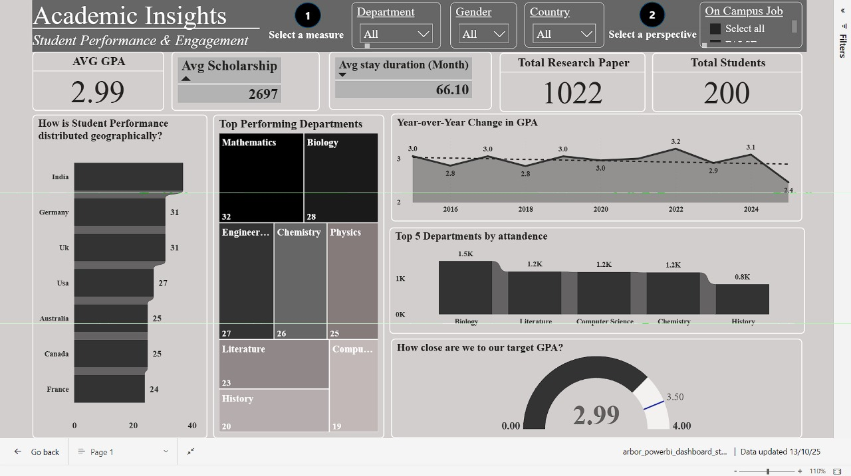

**#Lecture 5: Github Project Upload | Project (Analyse Hotel Data)**

**Project: Hotel Management**

Analyze Hotel Data to discover important factor that governs the Hotel.

**In 3 days we will cover:**

* How to create Report (30-40 Page Report- with help of Gen AI)
* How to create Dashbaord (Daily Sales & Yearly Sales two dashboards)
* How to create PPT(Report & Dashboard are present on PPT)

**Report:** Har ek chart ke Hmara business perspective kya hai?

**PPT:** it will represent graph(From Dashboard) and reports (Points)

**#Basic Data cleaning ke 5 steps:**

1. Remove Errors
2. Remove Blank space
3. Remove duplicate
4. Identify primary key
5. Identify null values from each column,
6. Use Trim and clean from Format option

***We will create 4 sheets***

**Sheet 1.** Know your data/clean your data(KYD-Data Cleaning)

Data me error remove krne ke baad kitna record bacha, wo bataege

**Sheet 2.** Know your variables(Columns)( KYV-Columns)

**Sheet 3.** Data Wrangling / Feature Engineering / Data Transformation

**Sheet 4**. KPI / Charts

***Data records: 1 Lac 20 thousand and 32 columns***

Tip: Jab bhi hamare pas 1 cr , 2cr huge amount me data rehte hai to generally hum 200-300 records data se randomly pick kr lete hai and excel sheet me rakhte hai and usko analyze krte hai ki aage kya krna hai.

**#What is Data Wrangling?**

What we have done with the data, that comes under data wrangling.

**#What is Data Cleaning?**

Data Cleaning me Identification hota hai. But data wrangling me wo sari cheeze perform karte hai.

**#Data cleaning and data wrangling is different ?**

Inko dono ko alag rakh sakte hai but ye dono step apas me ek dusre se dependent hai.

#Suppose primary key add krna hai to ye data wrangling me ayega kyu ki action perform kr rahe hai.

But agar new feature add kare rahe hai jaise primary key add krna, wo data cleaning se identify hoga, to ye keh sakte hai dono ek dusre se dependent hai.

#Null value identification: Data Cleaning

#Null value filling: Data wrangling

**##EDA(Exploratory Data Analysis)**

[**Github Link of Hotel management project**](https://github.com/abhiwavhal/EDA-HOTEL-BOOKING-ANALYSIS/blob/main/Hotel_booking_individual_EDA_Submission.ipynb)

**#Lecture 6: Data Cleaning(Left part of lecture 5) | PPT Presentation**

**Project: Hotel Management**

Agar suppose null value kisi col me jada hai to usko directly remove kr do and agar null values kam hai like 5-10 out of 1000 rows data to usko replace with zero kr sakte hai.

**Replace Kaise karege? (How to deal with NULL values for both categorical and numerical cols)**

Us column me click karege filter option, select 0 or null , it will show you how many these type of values it have. Then replace karo something like “ghdgg” or “null” or “Error” and than change the data type accordingly and finally it will show you the Error in column then select that row and remove errors.(Numerical col)

#For categorical col, identify clue or idea, Ya to most values se replace kro ya logical answer se replace kro, suppose 60% people choose India rather than other country, then India hi fill kro NULL values me.

## Suppose I have a column name “Salary” and it contains 1000 rows, jisme se 2-3 log ki salary null hai, us case me , null value ki jagah MODE (most repeated value )nikal kr fill kr sakte hai ya sabki salary ka avg nikal kr fill kr sakte hai,

Agar kisi col me 90% se upar data NULL hai to us col ko hi del kr do.

**##Report kaise Banaye?**

**#PPT**

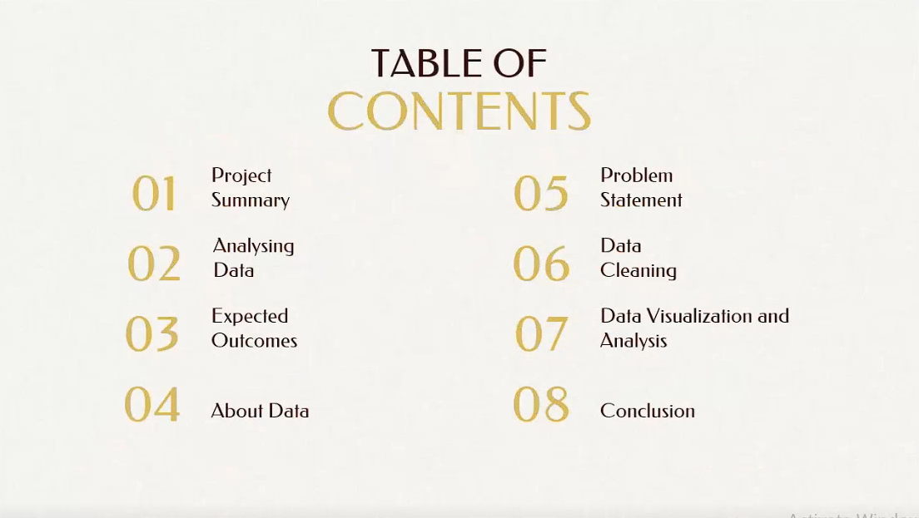

##Slide 2: Project Summary



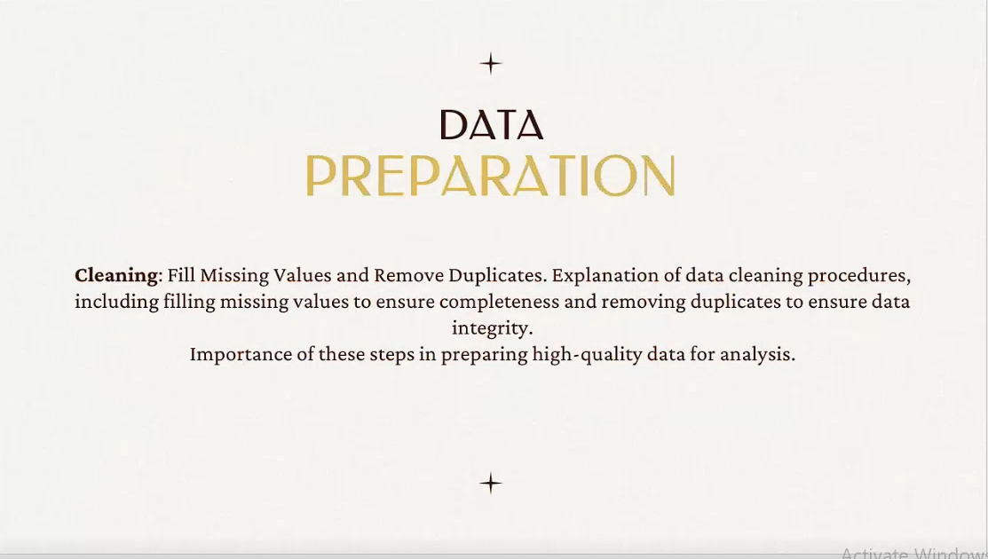





**##Slide 3: Expected OutComes**





**##Slide 4: About Data**

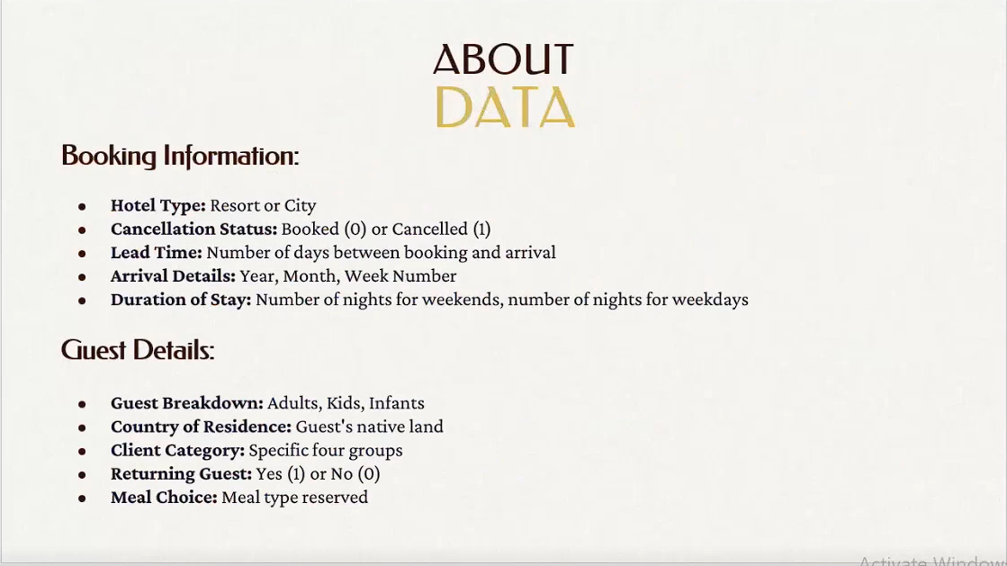

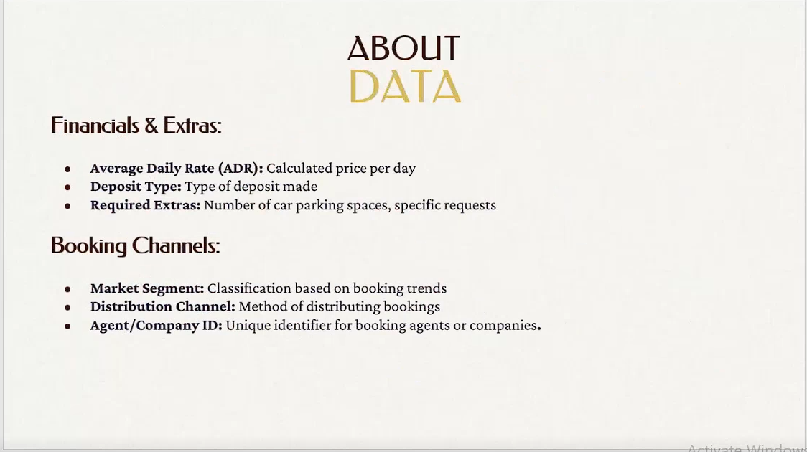

**##Slide 5: Problem Statement**

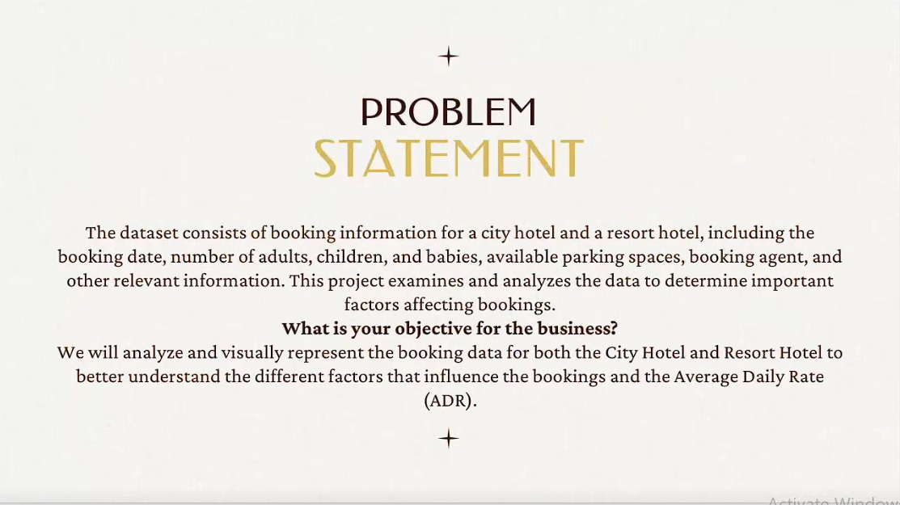

**##Slide 6: Data Cleaning**

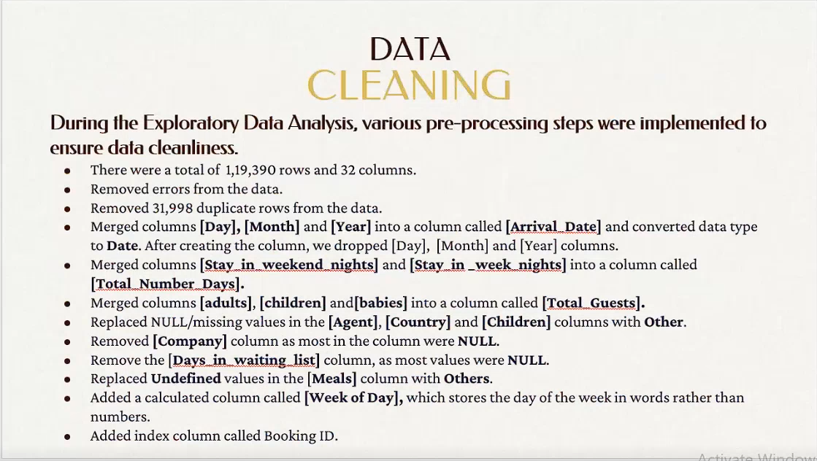

**##Slide 7: Data Visualization & Analysis**

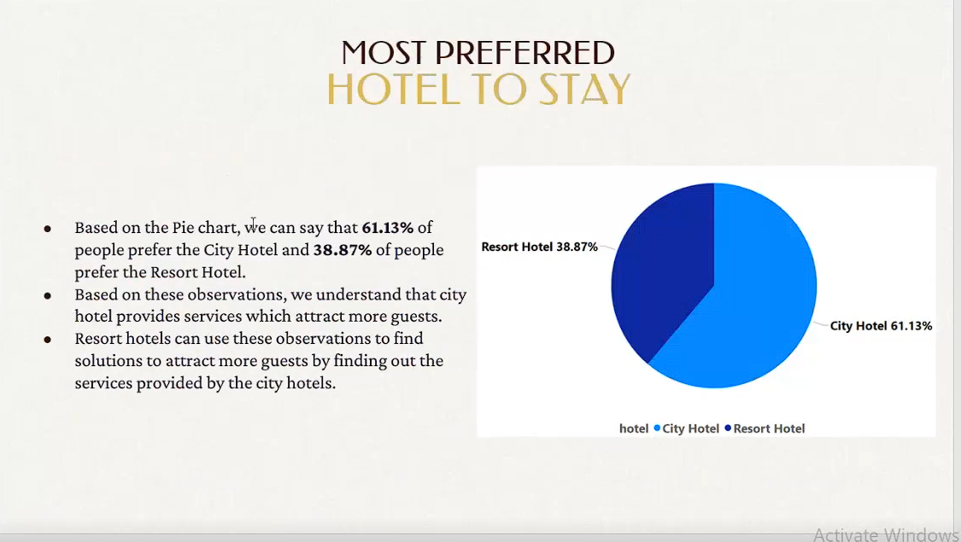

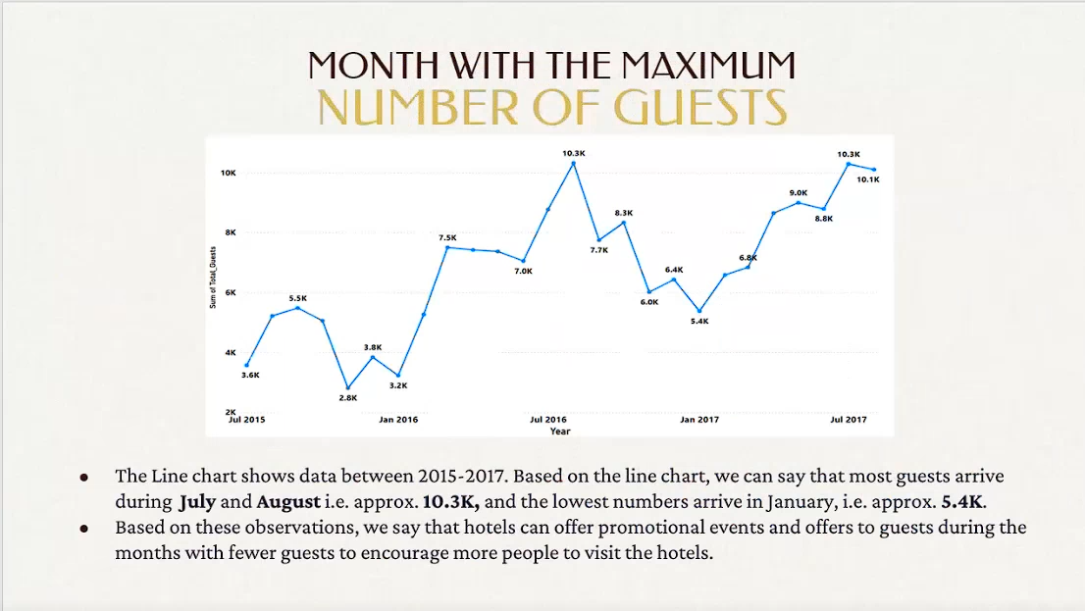

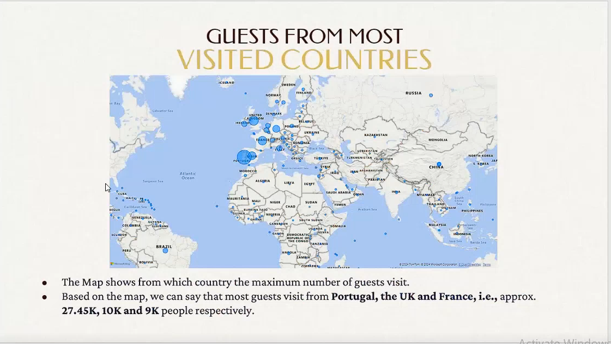

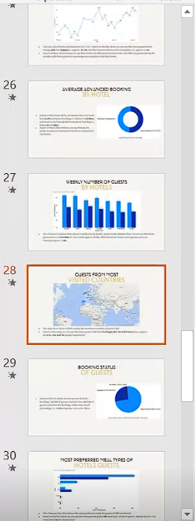

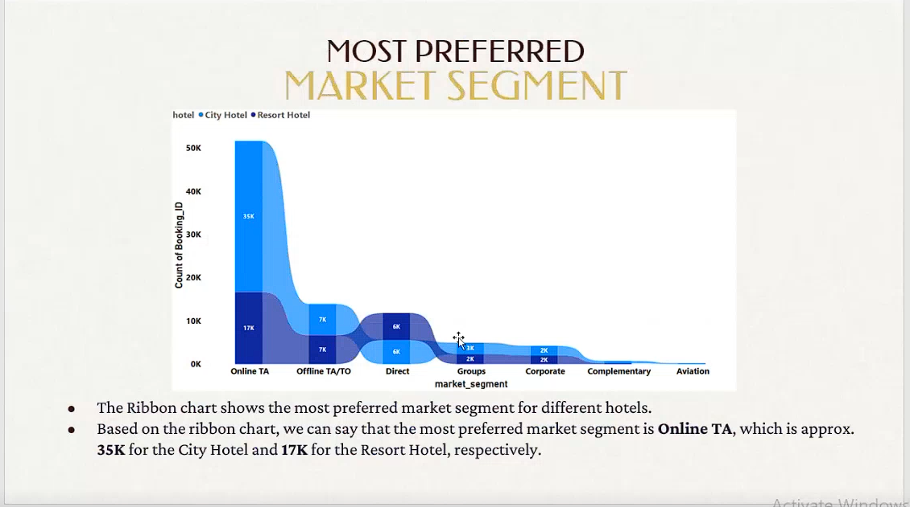

**#Slide: Weekly and annual insights + Dashboards**

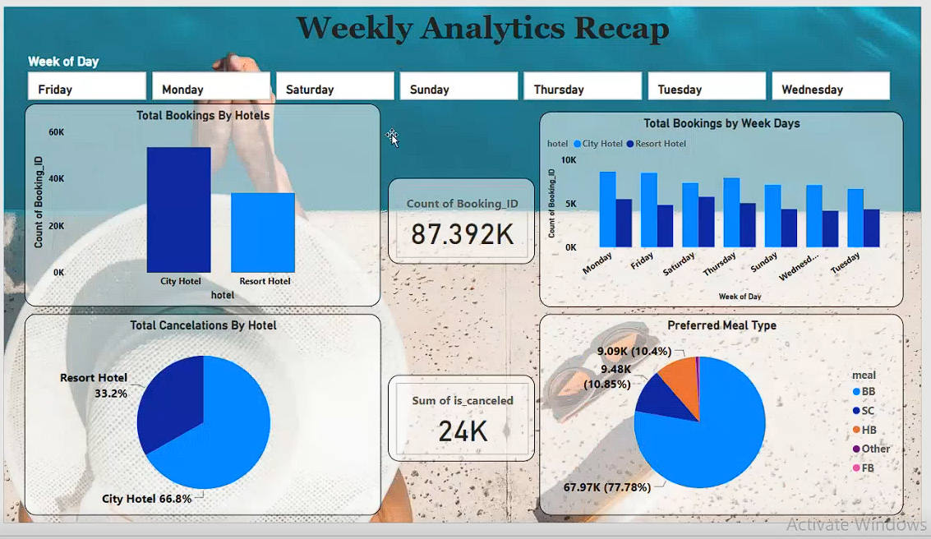

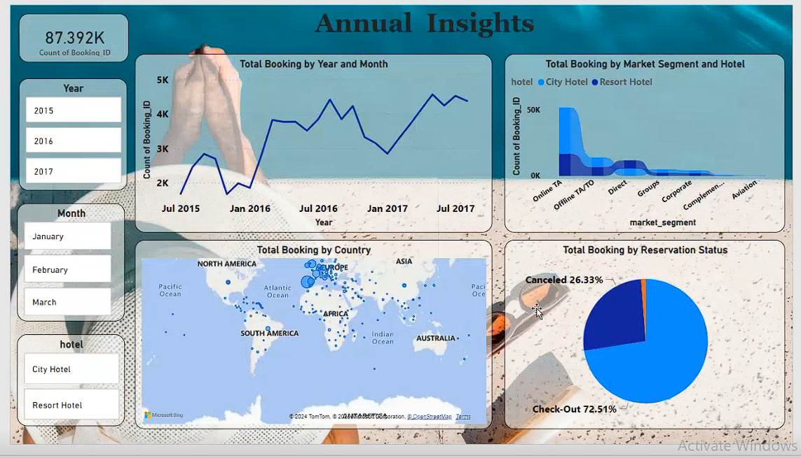

**##Slide 8 Conclusion**

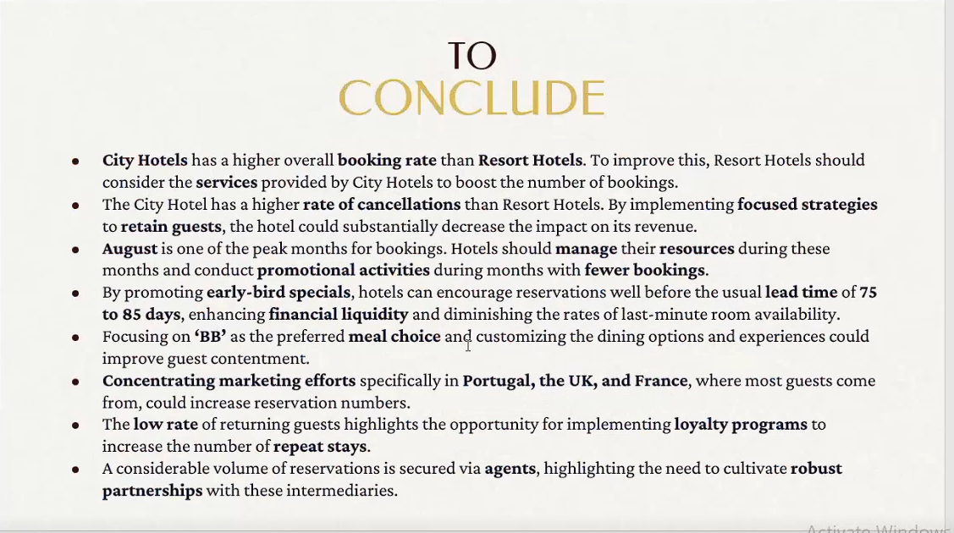

**### 6 Dashboards Given by Trainer**

**Dashboard 1: Previous Page (Student Insights Dashboard)**

**Dashboard 2: Sales Achievement and Performance Overview**

***A Power BI Dashboard showing regional performance, target achievements, and key sales insight***

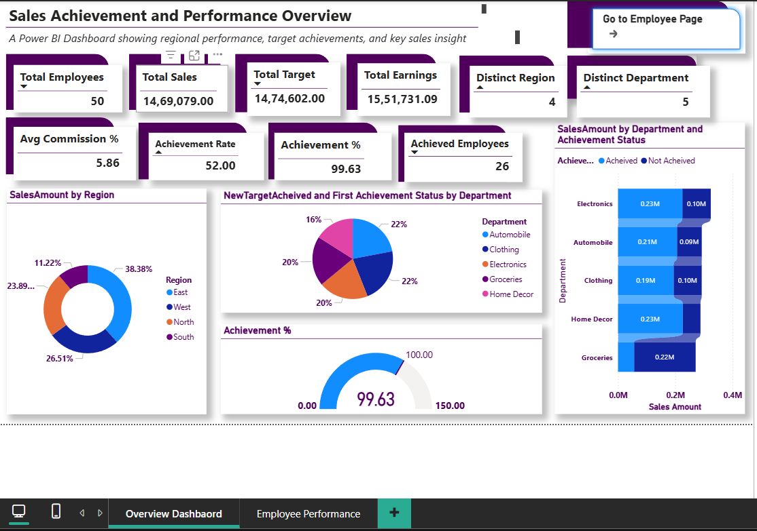

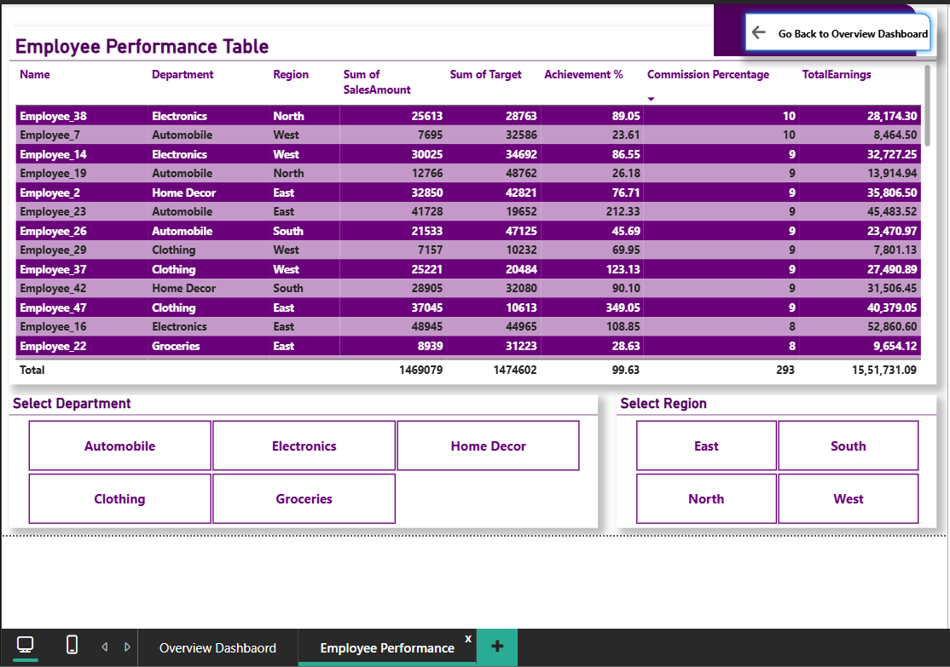

[**#Dashboard 3 Hotel Data**](https://chatgpt.com/c/68fb5a4e-4e54-8320-97c4-3418e22b102c)

**1) Overview — end-to-end process (high level)**

1. **Get data (Power BI Desktop → Get Data → Excel → choose sheet).**
2. **Profile & inspect (Power Query Editor: view sample rows, column types, column statistics).**
3. **Clean & transform (trim, remove duplicates, correct types, split columns, normalize values, handle missing/invalid data).**
4. **Fix date/time issues (see section 3 for the CheckInDate problem).**
5. **Load to model (Close & Apply → create relationships if multiple tables).**
6. **Modeling (set table types, hide unneeded columns, define calendar table/date table, create relationships).**
7. **Create measures (DAX measures for KPIs like total bookings, ADR, occupancy, RevPAR, cancellations).**
8. **Design visuals (cards, line charts, matrix, bar charts, slicers, map visual for Location).**
9. **Polish & UX (tooltips, drillthrough, bookmarks, slicer sync, conditional formatting).**
10. **Publish & refresh (Publish to Power BI Service, configure refresh/gateway, share dashboards).**

**Below I expand each step with practical tasks and tips.**

**2) Practical step-by-step in Power BI Desktop**

**A. Get data**

1. **Open Power BI Desktop → Get Data → Excel → pick arbor_powerbi_hotel_data.xlsx.**
2. **In Navigator select hotel_data(1) and click Transform Data (so you enter Power Query Editor).**

**B. Inspect & profile**

1. **In Power Query view the first 1,000 rows and column headers.**
2. **Turn on profiling: View → Column quality / Column distribution / Column profile. This surfaces nulls, distinct values, and errors.**
3. **Note columns that need cleaning (e.g., PricePerNight might be text/currency, CheckInDate may be DateTime/text).**

**C. Basic cleaning (recommended order)**

1. **Remove leading/trailing spaces: select text columns → Transform → Format → Trim.**
2. **Standardize case (if needed): Format → Lowercase/Uppercase/Capitalize.**
3. **Replace common bad values: Home → Replace Values (e.g., “N/A”, “-” → null).**
4. **Filter out test rows: e.g., filter HotelName if contains “test”.**
5. **Remove duplicates (if each booking should be unique): Home → Remove Rows → Remove Duplicates.**
6. **Split columns (if needed): text columns that hold compound info (e.g., “City, State”).**

**D. Data type changes (general)**

* **Do most data-type changes after cleaning. Use Transform → Data Type.**
* **If a change produces errors, use the “Keep Errors” / “Remove Errors” tools to inspect problematic rows.**
* **For numbers with currency symbols: transform to text → remove "$" and commas via Replace Values → change type to Decimal Number.**

**E. Date/dateTime handling (see next section for CheckInDate specifics)**

* **Establish a Date table (important for time intelligence). Create it in Power Query or use CALENDARAUTO() in DAX.**
* **Mark the Date table as the Date Table (Modeling → Mark as date table).**

**F. Close & Apply**

* **After transformations click Home → Close & Apply to load data into the model.**

**G. Create relationships & model**

* **In Model view, create relationships between fact tables and dimension tables (e.g., link bookings to hotels/calendar).**
* **For performance: hide original intermediate columns, reduce cardinality when possible, and set appropriate storage mode.**

**H. Create measures (DAX) — common hotel KPIs**

**Examples (adjust column/table names to yours):**

* **Total Bookings**

**TotalBookings = COUNTROWS('hotel_data(1)')**

* **Total Revenue**

**TotalRevenue = SUM('hotel_data(1)'[PricePerNight])**

***(if you have nights × price, use SUMX over rows)***

* **Average Daily Rate (ADR)**

**ADR = DIVIDE( [TotalRevenue], [TotalRoomsBooked] )**

***(define TotalRoomsBooked appropriately)***

* **Occupancy Rate (if you have capacity data)**

**OccupancyRate = DIVIDE( [OccupiedRooms], [TotalRoomsAvailable] )**

* **Bookings by Channel / RoomType: simple SUMX/CALCULATE with filters.**

**I. Build the report / dashboard**

* **Top row: KPI cards (Total Bookings, Revenue, ADR, Occupancy %).**
* **Left: Filters / slicers (Date range, Location, RoomType, BookingStatus).**
* **Center: Trend line (Bookings over time, Revenue over time).**
* **Right: Breakdown visuals (bar chart by RoomType, stacked column by BookingStatus).**
* **Bottom: Map visual for Location (if you have coordinates or city names).**
* **Use drillthrough pages to inspect single Hotel/RoomType. Use tooltips for extra data points.**

**J. Polishing**

* **Add conditional formatting for KPIs (green/red).**
* **Use bookmarks for report states (e.g., “Executive Overview”, “Operations”).**
* **Configure visual-level tooltips and report-level filters.**
* **Add export buttons (bookmark + action) or Subscribe in Power BI Service.**

**K. Publish & schedule refresh**

1. **Publish to Power BI Service: Home → Publish.**
2. **If Excel file is on OneDrive/SharePoint, connect via those connectors for easier refresh.**
3. **For local files, install and configure an on-premises data gateway then schedule refresh.**
4. **Share dashboard or app with stakeholders; set row-level security (RLS) if required.**

**3) The CheckInDate → Date problem — diagnosis and fixes**

**You said checkInDate (your file has CheckInDate) is in date/time format in Power BI but converting to Date throws an error. Common root causes and fixes follow.**

**Why conversion can fail (common causes)**

1. **Non-convertible values in column (e.g., "N/A", "-", or other text).**
2. **Mixed types in the column (some cells are DateTime, others text). Power Query sometimes stores the column as Any and converting will error on bad cells.**
3. **Locale mismatch — date strings in dd/MM/yyyy but Power Query assumes MM/dd/yyyy.**
4. **Hidden characters (non-printing whitespace or BOM).**
5. **Time zone / DateTimeZone text formats that need a different parser.**
6. **Nulls or blank cells that are not recognized properly.**

**How to diagnose in Power Query**

1. **In Power Query, select CheckInDate column.**
2. **On the Transform ribbon, click Detect Data Type or try to set Data Type → Date.**
3. **If errors appear, click the error indicator (yellow triangle) at the column header or use Home → Keep Rows → Keep Errors. That shows the rows that fail conversion.**
4. **Inspect those rows to see what's different (text like “TBA”, different date format, empty strings).**

**Quick safe approach (Power Query) — recommended**

**Use a safe conversion that attempts to parse various formats and returns null for bad values. Put this step after cleaning Replace Values for common placeholders:**

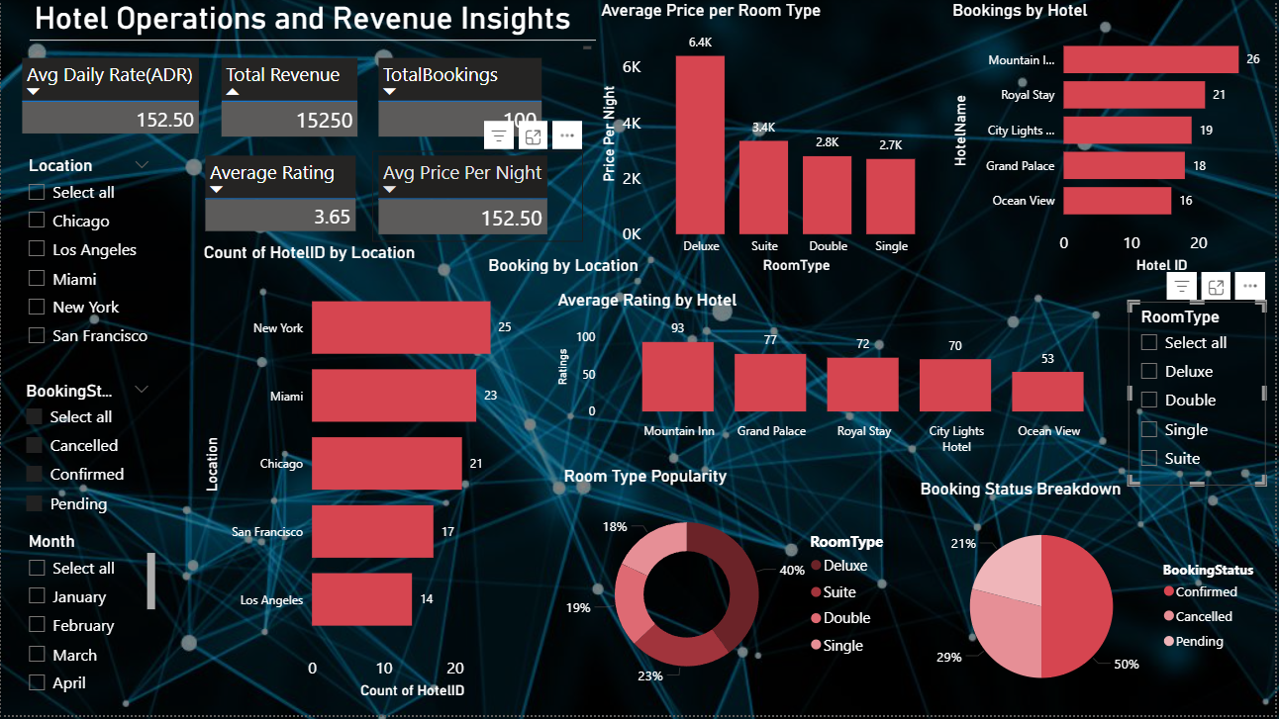

**[#Dashboard 4 Employee Data](https://chatgpt.com/c/68fba79a-def0-8321-b466-0fa59b97e330)**

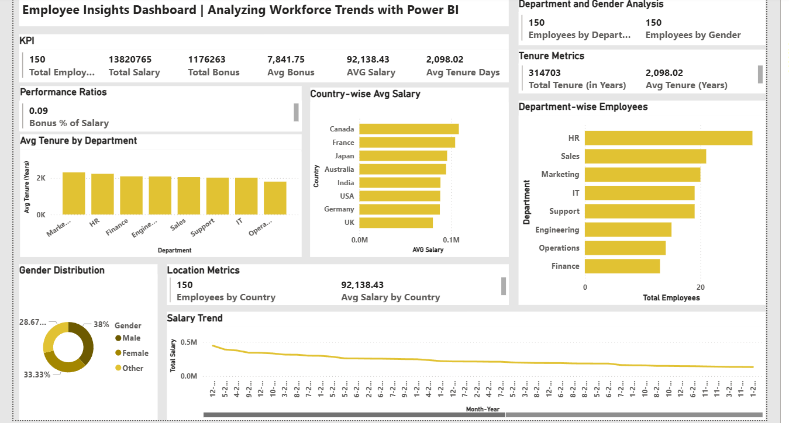

[**#Dashbaord 5: Car Data**](https://chatgpt.com/c/68ff86d0-b3fc-8323-ab6d-9d3da44d45ff)

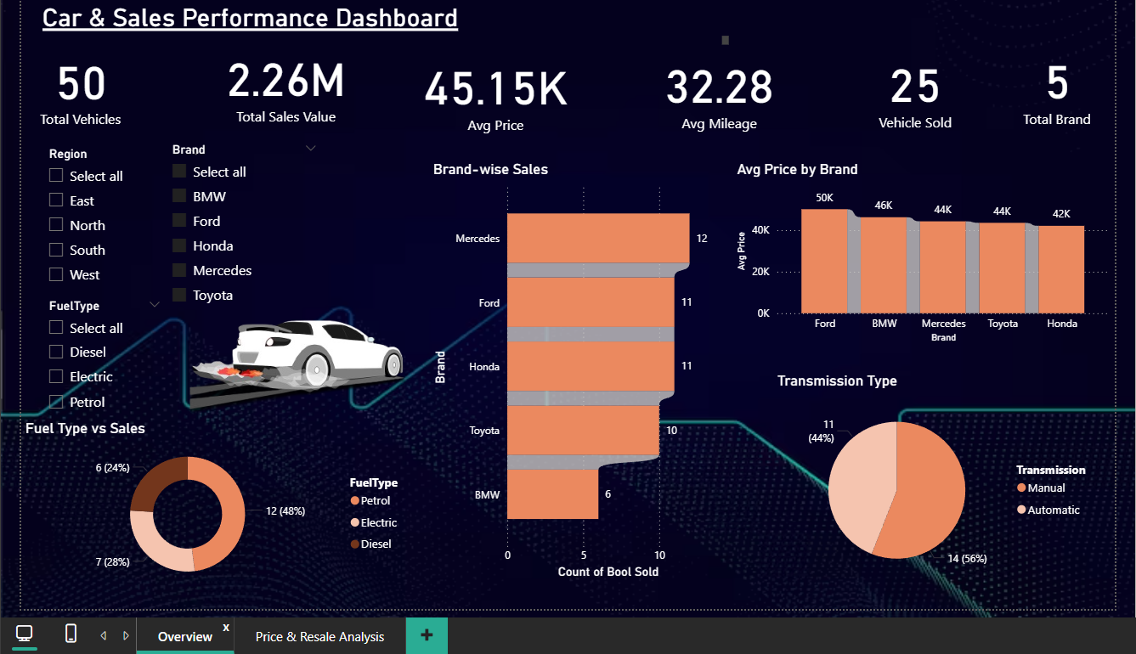

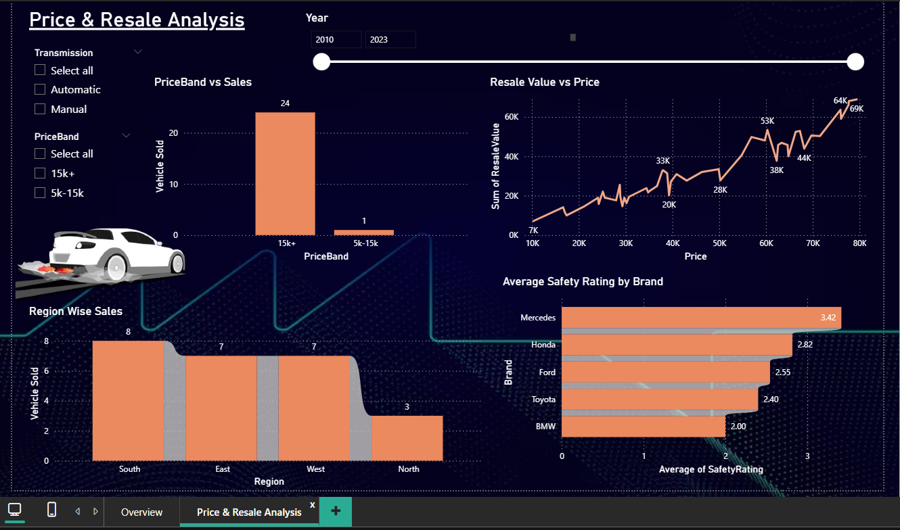

[**#Dashboard 6: Airline Passengers**](https://chatgpt.com/c/69010c17-81e8-8324-8325-630c5af49cb1)

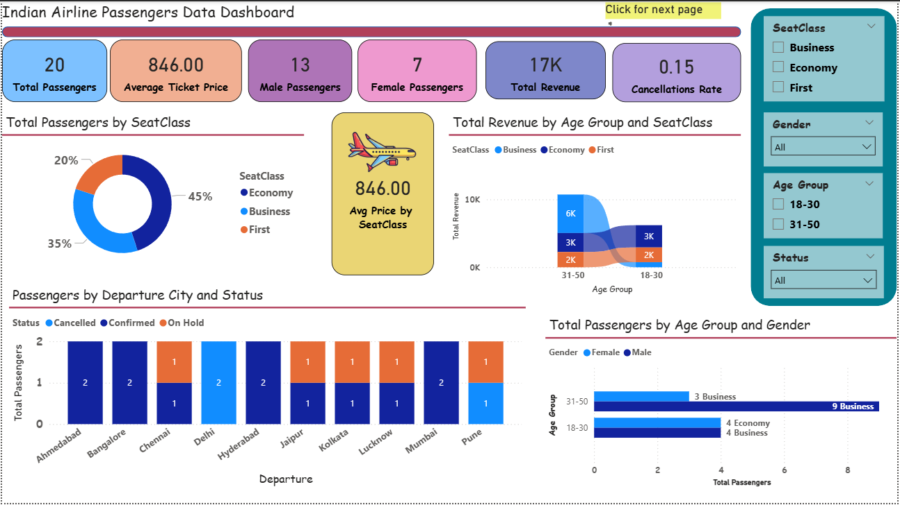

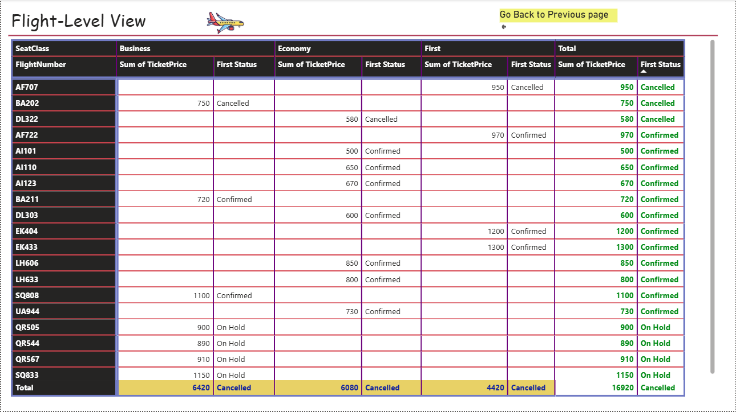

#Lecture : 31 Oct 2025(Last lecture was on friday)

**#Cross filter navigation**

**#Page Navigation**

**#Buttons**

**#Slicer: Sync slicer**

**#Q and A section:** By double click on the dashboard in blank space

* Button(Blank button) ke through be Q/A de sakte hai.

**#Include and Exclude**

**#show as a table**

**#show as data point**

**##Project: Hotel Booking Dashboard | Data Analysis Project with PPT Presentation**

**Hotel Bookings — Power BI Project Plan & Deliverables**

This canvas contains a complete, manager-ready plan for your Hotel Bookings Power BI project. It matches the six sheets in your workbook and provides concrete, step-by-step actions you can copy into each sheet: **KYD (Data Cleaning), KYV (Know Your Variables), Data Transformation/Wrangling, Storytelling & KPI Charts, and Final Report**. I analyzed the Hotel_Bookings_(1)(1) sheet (119,390 rows, 32 columns) and produced targeted recommendations and DAX formulas based on the actual column names.

**1) Executive summary (what to put in the Report sheet)**

* **Project objective:** Build an interactive Power BI dashboard to monitor hotel performance (bookings, cancellations, revenue trends, channels, guest behavior) and provide actionable recommendations to operations and revenue teams.
* **Data source:** Excel workbook arbor_project_hotelbookings_powerbi.xlsx — main table Hotel_Bookings_(1)(1) (119,390 rows, 32 columns).
* **Key findings (quick bullets to include after you finish analysis):** e.g., cancellation rate, average ADR, months with highest revenue, channels with highest cancellations. (Fill these with actual numbers after building visuals.)
* **Recommendation summary:** e.g., tighten cancellation policy for specific channels, target markets/countries for marketing, dynamic pricing suggestions for low ADR months.

**2) KYD — Know Your Data (Data Cleaning steps to write in the KYD-DataCleaning sheet)**

Write each step as an action item you performed. Use the exact column names from the dataset.

1. **Initial checks**
   * Confirm row count: 119,390 and columns: 32.
   * Check data types and null counts for all columns.
2. **Missing values**
   * children has 4 missing → replace NaN with 0 (logical: no children recorded).
   * country has 488 missing → set to Unknown or NA and, where appropriate, exclude from country-level maps/analysis or group as Other.
   * agent has 16,340 missing → set to Unknown/Direct (many direct bookings have no agent). Keep original numeric id but create agent_clean with Unknown for nulls.
   * company has 112,593 missing → fill with None or Not Provided (most bookings are individual customers). Keep as string category No Company.
3. **Invalid / suspicious values**
   * adr minimum is -6.38 and maximum 5400.0. Negative ADR is invalid — set negative adr values to NaN and mark them for review or drop those rows if they are few.
   * Extremely high ADR (e.g., > 2000) — mark as outliers; verify with reservation reference or cap at a business-justified threshold if needed.
4. **Duplicates**
   * Check if entire rows are duplicated: drop exact duplicates after validating unique reservation identifiers (if available). If there is no single reservation id, use the composite (hotel, reservation_status_date, arrival_date_year, arrival_date_month, lead_time, adults, children, babies, adr) to detect near-duplicates.
5. **Date fields**
   * Create a proper arrival_date by combining arrival_date_year, arrival_date_month, and arrival_date_day_of_month.
   * Convert reservation_status_date to Date type (already datetime in the file).
   * Derive booking_date = arrival_date - lead_time days (use lead_time to compute the booking date). Validate that booking_date <= reservation_status_date for non-cancelled bookings.
6. **Categorical cleaning**
   * Standardize text fields: hotel, meal, market_segment, distribution_channel, reserved_room_type, assigned_room_type, deposit_type, customer_type, reservation_status — trim whitespace, fix capitalization and typos.
   * For country, map country codes to full country names if needed for presentation (or use codes on maps).
7. **Numeric types**
   * Ensure children type is integer after filling nulls.
   * Convert agent and company to string categories (they are numeric IDs but will be used as categorical keys).
8. **Add flags**
   * is_family_booking = 1 if children + babies > 0 else 0.
   * total_nights = stays_in_weekend_nights + stays_in_week_nights.
   * total_guests = adults + children + babies.
9. **Save a clean copy**
   * Save the cleaned table as Hotel_Bookings_Clean CSV/Excel for Power BI import.

**3) KYV — Know Your Variable (what to put in the KYV-Columns sheet)**

List columns, type, brief description, and action (clean/transform/use). Example table rows (you can paste into the KYV sheet):

* hotel — (Categorical) Hotel type (City Hotel / Resort Hotel). Use to segment dashboards.
* is_canceled — (Binary) 1 = cancelled, 0 = not cancelled. Use to compute cancellation KPIs.
* lead_time — (Numeric) Days between booking and arrival. Outliers possible — cap or analyze distribution.
* arrival_date_year — (Numeric) Year of arrival. Use for yearly trends.
* arrival_date_month — (Categorical) Month of arrival. Convert to month number for sorting.
* arrival_date_day_of_month — (Numeric) Day of month.
* stays_in_weekend_nights — (Numeric) Nights stayed on weekend.
* stays_in_week_nights — (Numeric) Nights stayed on weeknights.
* adults, children, babies — (Numeric) Guest counts. Fill missing children as 0.
* meal — (Categorical) Meal plan type.
* country — (Categorical) Country code of origin. Clean Unknown.
* market_segment, distribution_channel — (Categorical) Useful for channel/campaign analysis.
* is_repeated_guest — (Binary) 1 = repeat guest.
* previous_cancellations, previous_bookings_not_canceled — (Numeric) Historic behavior.
* reserved_room_type, assigned_room_type — (Categorical) Room types.
* booking_changes — (Numeric) Count of booking changes.
* deposit_type — (Categorical) (No Deposit / Non Refund / Refundable).
* agent, company — (Categorical IDs) Most values missing; treat as Unknown when null.
* days_in_waiting_list — (Numeric)
* customer_type — (Categorical) e.g., Transient, Contract.
* adr — (Numeric) Average Daily Rate. Clean negative values.
* required_car_parking_spaces — (Numeric)
* total_of_special_requests — (Numeric)
* reservation_status, reservation_status_date — (Categorical/Date) Final status and the date.

Add a short note column: Action — e.g., Fill missing / Convert type / Create derived field.

**4) Data transformation / Wrangling (what to put in DataTransformation-Wrangling sheet)**

Write the exact transformation steps you will do in Power Query or Python before loading into Power BI. Example steps (copy into the worksheet):

1. **Load** Hotel_Bookings_(1)(1) into Power Query.
2. **Replace nulls**: children → 0; country null → Unknown; agent null → Unknown; company null → No Company.
3. **Filter/flag invalid ADR**: filter rows where adr <= 0 or set adr to null and add adr_flag = Invalid for rows with adr <= 0.
4. **Combine arrival date**: arrival_date = Date.FromText(Text.From(arrival_date_year) & "-" & Text.From(Date.Month(Date.FromText(arrival_date_month & " 1"))) & "-" & Text.From(arrival_date_day_of_month)) — or use Date.From(Date.AddMonths(#date(arrival_date_year, 1, arrival_date_day_of_month), monthNumber-1)) approach in PQ. (Power Query provides Date.FromText and Date.AddDays functions.)
5. **Compute booking_date**: booking_date = Date.AddDays(arrival_date, -lead_time).
6. **Derived measures**:
   * total_nights = stays_in_weekend_nights + stays_in_week_nights.
   * total_guests = adults + children + babies.
   * is_family = if (children + babies) > 0 then 1 else 0.
   * revenue = adr * total_nights (create revenue column; deal with nulls in adr).
   * arrival_monthnum = Date.Month(arrival_date) and arrival_monthname = Date.MonthName(arrival_date) and arrival_ym = Date.ToText(arrival_date, "yyyy-MM").
7. **Cap or flag outliers**: create adr_outlier_flag where adr > mean + 3*std or adr < 0.
8. **Create lookup tables (optional)**:
   * DimHotel (hotel types)
   * DimCountry (country names and region mapping)
   * DimAgent (agent id → agent name / grouping)
9. **Load to Data Model**: Load the cleaned table and lookup tables into Power BI data model.

**5) Storytelling / KPI Charts (what to put in StoryTelling-KPI-Charts sheet)**

Describe what each visual answers and which KPI to show. Also provide suggested chart type and any DAX formulas.

**Required KPI cards (top of dashboard)**

* **Total Bookings** = Total Bookings = COUNTROWS('Hotel_Bookings_Clean')
* **Total Revenue** = Total Revenue = SUM('Hotel_Bookings_Clean'[revenue])
* **Avg ADR** = Avg ADR = AVERAGE('Hotel_Bookings_Clean'[adr])
* **Cancellation Rate (%)** =

Cancellation Count = CALCULATE(COUNTROWS('Hotel_Bookings_Clean'), 'Hotel_Bookings_Clean'[is_canceled]=1)

Cancellation Rate = DIVIDE([Cancellation Count], [Total Bookings], 0)

* **Average Lead Time (days)** = Average Lead Time = AVERAGE('Hotel_Bookings_Clean'[lead_time])
* **Repeat Guest Rate (%)** = Repeat Guest Rate = DIVIDE(CALCULATE(COUNTROWS('Hotel_Bookings_Clean'), 'Hotel_Bookings_Clean'[is_repeated_guest]=1), [Total Bookings])

**Time series & trend analysis**

* **Bookings by month (line)** — show trend of bookings and overlay revenue: dual-axis line (or line + area). Use arrival_date on X-axis aggregated by month-year. Add slicer for hotel (City/Resort).
* **Revenue by month (line/area)** — SUM(revenue) by month.

**Channel & market analysis**

* **Bookings by Market Segment / Distribution Channel (stacked bar / 100% stacked)** — helps identify sources of bookings and which segments cancel more.
* **Top 10 Countries by Revenue (map or bar chart)** — use country code; map visual or horizontal bar.

**Cancellation & behavior**

* **Cancellation Rate by Market Segment / Country / Month** — heatmap or bar chart of cancellation percentage.
* **Lead Time distribution histogram** — show how far in advance guests book.
* **Repeat guests vs One-time guests revenue** — compare is_repeated_guest groups.

**Pricing & revenue**

* **ADR distribution** — boxplot or histogram to show spread; flag outliers.
* **Revenue per booking by room type** — bar chart of SUM(revenue) by reserved_room_type.

**Operational insights**

* **Average length of stay by customer type** — AVERAGE(total_nights) per customer_type.
* **Special requests and parking needs** — count bookings with total_of_special_requests > 0 and required_car_parking_spaces distribution.

**Table / Drill-through**

* **Detailed bookings table** — allow drill-through into booking details and show reservation_status, reservation_status_date, agent, company.

**Filters / Slicers**

* Slicers for hotel, arrival_ym, market_segment, distribution_channel, country (top N + other), customer_type.

**6) Suggested DAX measures (copy into Power BI)**

Total Bookings = COUNTROWS('Hotel_Bookings_Clean')

Total Revenue = SUM('Hotel_Bookings_Clean'[revenue])

Avg ADR = AVERAGE('Hotel_Bookings_Clean'[adr])

Cancellation Count = CALCULATE(COUNTROWS('Hotel_Bookings_Clean'), 'Hotel_Bookings_Clean'[is_canceled]=1)

Cancellation Rate = DIVIDE([Cancellation Count], [Total Bookings], 0)

Avg Lead Time = AVERAGE('Hotel_Bookings_Clean'[lead_time])

Repeat Guest Count = CALCULATE(COUNTROWS('Hotel_Bookings_Clean'), 'Hotel_Bookings_Clean'[is_repeated_guest]=1)

Repeat Guest Rate = DIVIDE([Repeat Guest Count],[Total Bookings],0)

Total Nights = SUM('Hotel_Bookings_Clean'[total_nights])

Revenue per Night = DIVIDE([Total Revenue], [Total Nights], 0)

-- Weighted ADR (by nights):

Weighted ADR = DIVIDE(SUMX('Hotel_Bookings_Clean', 'Hotel_Bookings_Clean'[adr] * 'Hotel_Bookings_Clean'[total_nights]), SUM('Hotel_Bookings_Clean'[total_nights]), 0)

-- Cancellation rate by market segment example:

Cancellation Rate by Segment =

DIVIDE(

CALCULATE(COUNTROWS('Hotel_Bookings_Clean'), 'Hotel_Bookings_Clean'[is_canceled]=1),

CALCULATE(COUNTROWS('Hotel_Bookings_Clean'))

)

**7) Power BI build — Step-by-step (how to present in PPT and how to build)**

1. **Import**: In Power BI Desktop, Get Data → Excel → choose the cleaned sheet Hotel_Bookings_Clean (or load transformations from Power Query if done there).
2. **Transform data**: Use Power Query Editor to apply the Data Transformation steps from section 4. Close & Apply.
3. **Create Date Table**: New table Date = CALENDARAUTO() or build from MIN(booking_date) to MAX(arrival_date). Mark as date table and create relationships (Date[Date] -> Hotel_Bookings_Clean[arrival_date]).
4. **Modeling**: Create lookup tables (DimHotel, DimCountry) and ensure relationships are single-direction and star schema-like.
5. **Create Measures**: Add the DAX measures listed above.
6. **Design**: Create a 3-section report page layout — Header (logo, title, date range slicer), KPI strip (6 KPI cards), Main canvas (time series + channel charts), Right pane (filters & top lists).
7. **Interactivity**: Add drill-through by reservation_id (if available) or reservation_status_date and set tooltips with small visuals.
8. **Formatting**: Sort months properly using month number, use consistent number formats, and conditional formatting for KPI deltas (e.g., cancellation up/down).
9. **Performance**: If slow, reduce visuals, import only selected columns, enable aggregation, or use DirectQuery if data lives in a SQL DB.

**8) PPT Structure (slides to present to your manager)**

1. Title slide — Project name, your name, date, audience.
2. Objective & Dataset — objective, rows & columns, source.
3. Data cleaning summary — top 6 actions (show a before/after snapshot or counts).
4. Methodology — transformation steps, schema, DAX highlights.
5. Key KPIs & Insights — show 3–4 major visuals and callouts (numbers & short interpretation).
6. Deep dives — channel analysis, pricing insights, cancellations.
7. Recommendations — 3–5 actionable suggestions for operations/revenue.
8. Next steps — further data to collect (e.g., rooms available, cost per room), A/B test suggestions.
9. Appendix — data dictionary, transformation steps, DAX formulas.

**9) Presentation script (short bullets to say for each KPI slide)**

* "Total bookings stood at X; cancellations were Y% driven largely by Market Segment A and Country B — this impacts revenue by Z%."
* "ADR trend shows seasonal dips in Feb/Mar, we can implement targeted promotions to improve occupancy during those months."
* "Lead time distribution indicates most bookings arrive within N days — campaign windows should be planned accordingly."

**10) Next steps / Data gaps (to note in Report)**

* Need hotel-level **room inventory** and **available room nights** to calculate true occupancy and RevPAR.
* Consider connecting booking source (campaign id) for marketing ROI analysis.
* Enrich agent and company tables with names if you want partner performance reports.

**Appendix: Useful quick checks I ran on your data (for transparency)**

* Rows: 119,390.
* Columns: 32.
* children missing: 4.
* country missing: 488.
* agent missing: 16,340.
* company missing: 112,593.
* adr min: -6.38 (invalid), max: 5400.0 (outlier).

If you want, I can now:

* Export a ready-to-paste KYD table and KYV table for your exact workbook format.
* Generate the Power Query (M) steps or a transforming Python script to create Hotel_Bookings_Clean automatically.
* Produce a slide-by-slide PPT (editable) with screenshots placeholders.

Tell me which of the above you'd like me to generate automatically next and I will create it for you.

**##Dashboard published in power bi service**

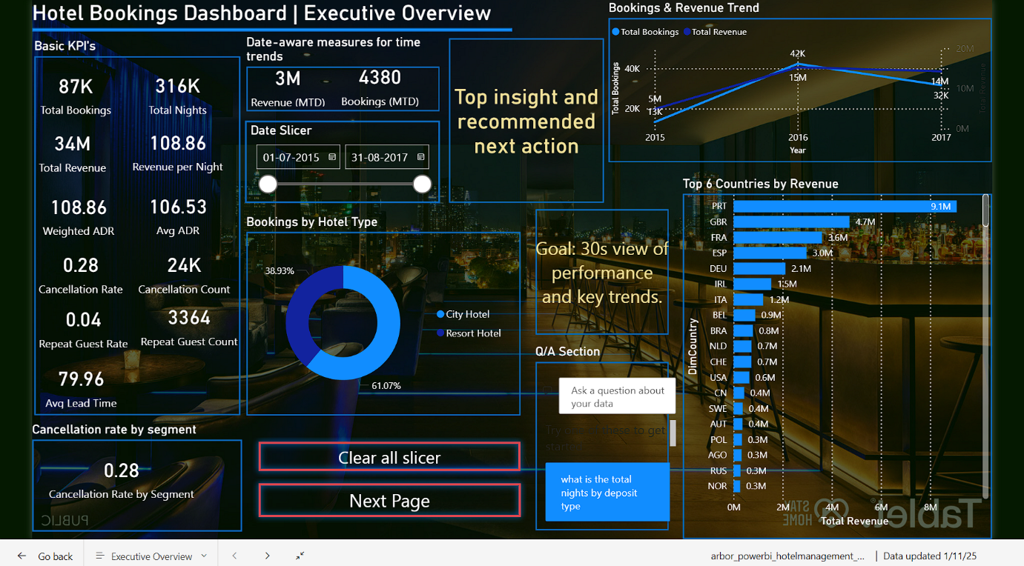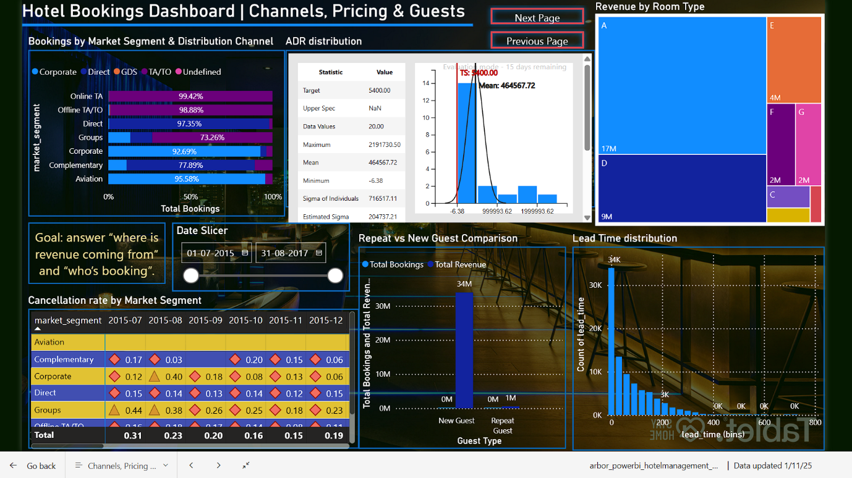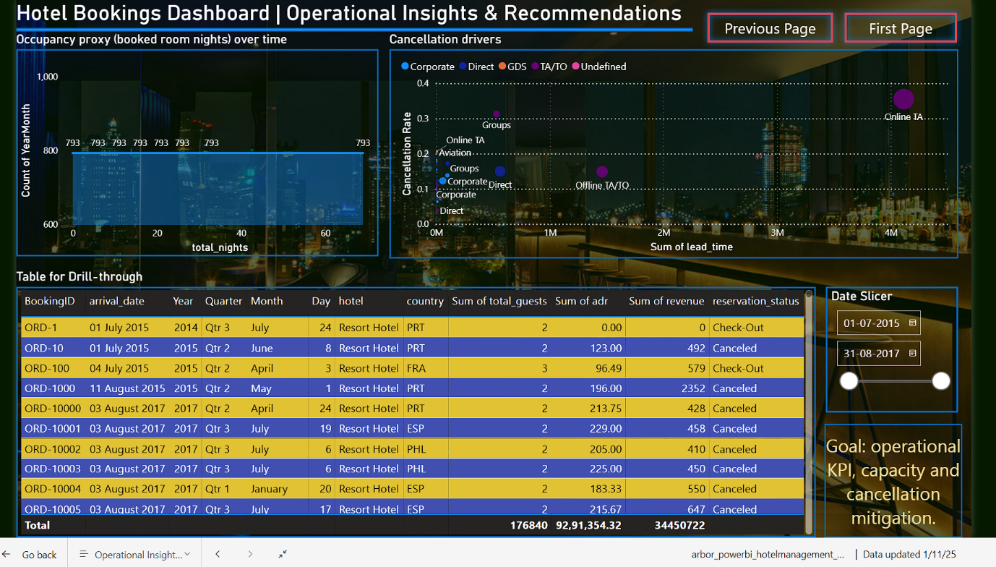

:

**🎤 Slide 1: Title Slide (Revised Opening Script)**

“Do you know that in the hospitality industry, even a small change in customer behavior or booking trend can directly impact millions in revenue?

Hi everyone, my name is **Anushree Kashyap**, and today I’m excited to share my **Hotel Booking Data Analysis Project** built using **Power BI**.

In this project, I explored real booking data from both **City Hotels and Resort Hotels** to understand how guests book, cancel, and stay — and how these patterns affect overall business performance.

**Slide 2: Project Overview**

“This project was given by AlmaBetter to analyze how the hotel group performs.  
The dataset covers 3 years — 2015 to 2017 — and includes booking and revenue details, number of guests, cancellations, stay duration, and more.  
It helps us compare the performance of City Hotel and Resort Hotel to understand which performs better and why.

**Slide 3: Problem Statement & Business Objective**

“The main problem was that the hotel management had no clear view of how bookings were behaving — for example, cancellations, guest types, or revenue by country.  
So, the business objective was to explore the data, identify booking patterns, and find what factors affect ADR, cancellations, and occupancy — all through an interactive Power BI dashboard.”

**Slide 4: What We Aim to Achieve**

“Our aim was to find what affects hotel bookings and cancellations, analyze trends by customer type and country, and understand how city and resort hotels differ.  
We also wanted to create a dashboard that helps management track revenue and occupancy easily and make data-based decisions.”

**Slide 5: Data Preparation**

“I divided the data preparation into three phases:

* **Know Your Data:** Checked data size, nulls, and data types.
* **Know Your Variables:** Understood which columns are useful for analysis.
* **Data Wrangling:** Created new fields like total stay, total guests, and revenue, removed errors, and made lookup tables for hotel, room, and country.”

**Slide 6: Data Cleaning**

“I handled missing values logically — for example, replaced missing children with 0, agent as ‘Unknown’, and company as ‘No Company’.  
Removed duplicates, corrected invalid ADR values, and standardized text formats.  
I also created new columns like total nights, total guests, and a family booking flag to enhance analysis.”

**Slide 7: Data Modeling & Dashboard Design**

“I used a **Star Schema** model with one fact table — Hotel_Bookings_Clean — and multiple dimension tables like hotel, country, and room.  
All tables were linked using keys for better analysis.  
I built three dashboards:

1. Executive Overview
2. Channels, Pricing & Guests
3. Operational Insights  
   Each focuses on different business goals.”

**Slide 8: Bookings by Hotel Type**

“This donut chart compares bookings between City and Resort Hotels.  
Around **61% bookings come from City Hotels**, showing higher demand in urban areas, while **39% are Resort bookings**.  
It shows that business travelers mostly prefer City Hotels, while Resorts need more promotion in off-season.”

**Slide 9: Total Booking & Total Revenue Trend**

“This line chart shows bookings and revenue over three years.  
We see growth till 2016 — around **42K bookings and 15M revenue** — but a decline in 2017.  
This means we need to check if cancellations or pricing caused this dip and take steps to stabilize growth.”

**Slide 10: Top 6 Countries by Revenue**

“This bar chart shows the top countries contributing to total revenue.  
**Portugal leads with 9.1M**, followed by the UK and France.  
This tells us that Portugal is the biggest customer base, so we can focus marketing and loyalty programs in these top regions.”

**Slide 11: ADR Distribution**

“This histogram shows the Average Daily Rate spread across bookings.  
Most ADRs fall between **₹4,500–₹18,000**, showing mid-range pricing dominates.  
It also shows a few outliers with higher prices — representing premium or long stays.  
This helps the business adjust room pricing more strategically.”

**Slide 12: Booking by Market Segment & Channel**

“This chart shows bookings by market segment and distribution channel.  
Most bookings come from **Online Travel Agencies**, followed by Direct and Corporate bookings.  
It means we depend heavily on OTAs, which take commissions — so the business should try to boost direct bookings through its website.”

**Slide 13: Repeat vs New Guest Comparison**

“This column chart compares new and repeat guests.  
Almost **96% of guests are new** and only **4% are repeat customers**, meaning low loyalty.  
This insight suggests launching **membership or loyalty programs** to retain customers.”

**Slide 14: Lead Time Distribution**

“This histogram shows how early people book their rooms.  
Most bookings are made within **0–100 days before arrival**, meaning guests usually plan last-minute.  
So, offering early-bird discounts or dynamic pricing can attract earlier bookings.”

**Slide 15: Revenue by Room Type**

“This tree map shows total revenue by room type.  
**Room Type A** generates the highest revenue, followed by D and E.  
This insight helps management promote these popular room types or use them for upgrade offers.”

**Slide 16: Occupancy Proxy (Booked Room Nights)**

“This area chart shows room occupancy over time.  
Occupancy peaks during **summer months — May to August**, showing seasonal demand.  
Hotels can plan staff and pricing accordingly to manage high demand and offer deals in off-season.”

**Slide 17: Cancellation Drivers**

“This scatter plot shows what’s driving cancellations.  
We can see **Online Travel Agencies and Group bookings** have higher cancellation rates, especially for long lead times.  
It means bookings made far in advance or through OTAs are more likely to cancel.  
To reduce this, the business can introduce **non-refundable bookings or deposit policies.**”

**Slide 18–20: Dashboard Pages**

“These are my three final dashboards:

* **Executive Overview:** for KPIs and performance summary
* **Channels, Pricing & Guests:** for revenue and customer insights
* **Operational Insights:** for cancellations and occupancy management  
  All are fully interactive with filters, navigation buttons, and Q&A support.”

**Slide 21: Recommendations**

“To summarize my recommendations:

* Use **Dynamic Pricing** to manage ADR changes
* Launch **Loyalty Programs** for repeat customers
* Offer **Non-Refundable rate plans** to control cancellations
* Focus **Marketing spend** on top-performing countries
* Build **Corporate partnerships** to reduce OTA dependency
* Encourage **longer stays** through bundled offers”

**Slide 22: Conclusion**

“To conclude:

* City Hotels dominate with **61% of bookings**
* **Portugal, UK, and France** generate most of the revenue
* **Online TA/TO** brings more bookings but also higher cancellations
* Room types **A and D** are top revenue contributors
* **July–August** is peak booking season
* Overall, by improving pricing strategy and customer retention, the hotel can increase revenue and reduce cancellations.”
* **🎤 Slide 22: Thank You Slide (Revised Ending Script)**
* “Thank you so much for your time and attention!
* This project really helped me understand how **data can tell a story** — about guests, revenue, and business performance.

I hope you enjoyed this walkthrough of my Hotel Booking Analysis dashboard

**#Seoul Bike Data Project**

**###Concept:**

**🧱 What “One-to-Many” and “Many-to-One” Mean**

A **relationship** in Power BI connects two tables through a column that appears in both (like Date in your case).

But Power BI also needs to know **how many matching values** each side can have —  
that’s what defines the **cardinality** (one-to-many or many-to-one).

**🔹 “One-to-Many” (1 → ∗)**

👉 Means:

* On the **left side** (the “1” side), each value appears **only once**.
* On the **right side** (the “many” side), each value may appear **multiple times**.

Example:

| **Calendar Table** |  | **Bike Data Table** |
| --- | --- | --- |
| Date | → | Date |
| 2023-01-01 | → | 2023-01-01 (hour 0) |
|  |  | 2023-01-01 (hour 1) |
|  |  | 2023-01-01 (hour 2) |

💡 Interpretation:

* **Calendar** has one unique row per date ✅
* **BikeData** has many rows per date (hourly records) ✅

So the **correct** direction is:

Calendar (1) ───▶ (*) BikeData

That’s the standard **One-to-Many** relationship for time intelligence.

**🔹 “Many-to-One” (∗ → 1)**

👉 Means the **direction is reversed** —  
you dragged the field *from the “many” side to the “one” side*.

So Power BI just shows the relationship direction based on which side you started dragging from — but it’s the **same logical connection**.

💡 In your case:

* When you drag **SeoulBikeData[Date] → Calendar[Date]**,  
  Power BI interprets that as **Many-to-One (∗ → 1)**.
* If you drag **Calendar[Date] → SeoulBikeData[Date]**,  
  you’ll see **One-to-Many (1 → ∗)**.

✅ Both are functionally identical.  
Only the **arrow direction** changes.

**🧠 Important: Which one is “correct”?**

Logically, the **Calendar table** should be the **“one” side** (unique dates),  
and your **BikeData table** should be the **“many” side** (repeated dates).

So the ideal structure is:

Calendar[Date] (1) ───▶ (∗) SeoulBikeData[Date]

Even if Power BI shows the arrow the other way (depending on drag),  
you can **flip it** or verify it:

**How to check:**

1. Double-click the line (relationship) in Model View.
2. A window pops up showing:
   * Cardinality: One-to-Many (or Many-to-One)
   * Cross-filter direction
3. Ensure it says:
4. Cardinality: One to many (1:*)

If not, select it manually.

Then click **OK** ✅

| **Relationship** | **Meaning** | **In Your Case** |
| --- | --- | --- |
| **One-to-Many (1 → ∗)** | Each value in first table appears once; in second, many times | Calendar → BikeData ✅ |
| **Many-to-One (∗ → 1)** | Reverse direction; same logic, just opposite drag | BikeData → Calendar |
| **Why it matters** | Ensures correct filtering & DAX time-intelligence | Calendar should filter BikeData |

So, in short:

You dragged from the “many” side (BikeData), so Power BI showed **Many-to-One** —  
but logically it’s the same relationship as One-to-Many, just reversed direction.  
The important part is: **Calendar = unique dates (1 side)**, **BikeData = repeated dates (many side)** ✅

**##Concept**what this means:

🧱 4. Add DAX Measures (the “semantic layer”) Now in Modeling → New Measure, define your key metrics (these belong to the model layer, not visuals): Total Rentals = SUM(BikeData[Rented_Bike_Count]) Avg Rentals = AVERAGE(BikeData[Rented_Bike_Count]) Total Functioning Days = COUNTROWS(FILTER(BikeData, BikeData[Functioning_Day] = TRUE())) Avg Temp = AVERAGE(BikeData[Temperature])

This helps your visuals stay consistent (always use measures, not raw columns). what is semantic layer? do you mean creating measure inside Modelling is different and creating measure in Report view(in dashboard directly) is different?

**🎯 What the “Semantic Layer” Means**

Think of your Power BI project as 3 layers:

| **Layer** | **What it does** | **Where you work** | **Example** |
| --- | --- | --- | --- |
| **1️⃣ Data layer** | Raw data (from Excel, SQL, etc.) | **Power Query (Transform Data)** | Cleaning columns, renaming, changing data types |
| **2️⃣ Semantic layer** | Adds *business meaning* to your data model | **Modeling view** | DAX Measures, relationships, hierarchies, calculated tables |
| **3️⃣ Visual layer** | Shows the data to users | **Report view (Dashboard)** | Charts, cards, slicers, filters |

So the **semantic layer** is the “brain” of your Power BI model —  
it defines **what metrics mean** (like “Total Rentals”, “Average Temperature”, etc.), independent of how you visualize them.

**🧱 Why Create Measures in the Semantic Layer**

When you go to:

Modeling → New Measure

and write:

Total Rentals = SUM(SeoulBikeData[Rented_Bike_Count])

you are defining a **reusable, centralized formula** — Power BI stores it in the model, not in a single chart.

✅ Benefits:

1. **Consistency:**  
   Every visual that uses “Total Rentals” will always calculate it the same way.
2. **Performance:**  
   Measures are optimized and only calculated when needed.
3. **Reusability:**  
   You can drag the same measure into multiple visuals, tooltips, or cards.
4. **Cleaner visuals:**  
   You don’t have to keep writing formulas in each chart — just use the measure name.

**⚠️ What happens if you create a measure in Report View**

When you click on a visual (like a Card) and do “New Measure” or use “Quick measure” there —  
it still technically creates a DAX measure,  
but it might get stored in that visual’s table or be harder to organize later.

**Best practice:**  
Always create measures in **Modeling view** (semantic layer),  
so your data model becomes your “single source of truth”.

Then, in Report View (dashboard),  
you simply **use** these measures — not build new ones there.

**🧠 Example in Your Bike Project**

Semantic Layer (Modeling view):

Total Rentals = SUM(SeoulBikeData[Rented_Bike_Count])

Avg Temperature = AVERAGE(SeoulBikeData[Temperature(°C)])

Total Functioning Days = COUNTROWS(FILTER(SeoulBikeData, SeoulBikeData[Bool_Functioning_day] = TRUE()))

Visual Layer (Report view):

* Card → “Total Rentals”
* Line Chart → Axis = Date, Values = “Total Rentals”
* Slicer → “Month”
* Tooltip → “Avg Temperature”

You’re not doing any math inside visuals — the model already knows the logic.

**🏗️ Summary**

| **Concept** | **Meaning** |
| --- | --- |
| **Semantic Layer** | The model logic (DAX measures, calculated columns, relationships) that gives *business meaning* to raw data |
| **Modeling View Measures** | Stored at model-level → reusable, clean, efficient ✅ |
| **Report View Measures** | Created ad-hoc inside visuals → less organized ⚠️ |
| **Best Practice** | Build all important measures in Modeling → use them in visuals |

